|  |  |
| --- | --- |
| **EXP:03**  **DATE:7.3.25** | **Java Servlet Program to Display 'HelloWorld!' in Browser** |
|  |  |

# AIM:

To write a servlet program that prints "HelloWorld!" and displays it in the browser when accessed.

# CODE:

#HelloWorld.java

package com.arunachalam.servlet; import java.io.IOException; import java.io.PrintWriter;

import javax.servlet.ServletException; import javax.servlet.annotation.WebServlet; import javax.servlet.http.HttpServlet;

import javax.servlet.http.HttpServletRequest; import javax.servlet.http.HttpServletResponse; @WebServlet("/HelloWorld")

public class HelloWorld extends HttpServlet {

private static final long serialVersionUID = 1L;

public HelloWorld() { super();

}

protected void doGet(HttpServletRequest request, HttpServletResponse response)

throws ServletException, IOException {

PrintWriter p = response.getWriter(); p.println("HelloWorld!");

}

protected void doPost(HttpServletRequest request, HttpServletResponse response) throws ServletException, IOException {

doGet(request, response);

}

}

# OUTPUT:

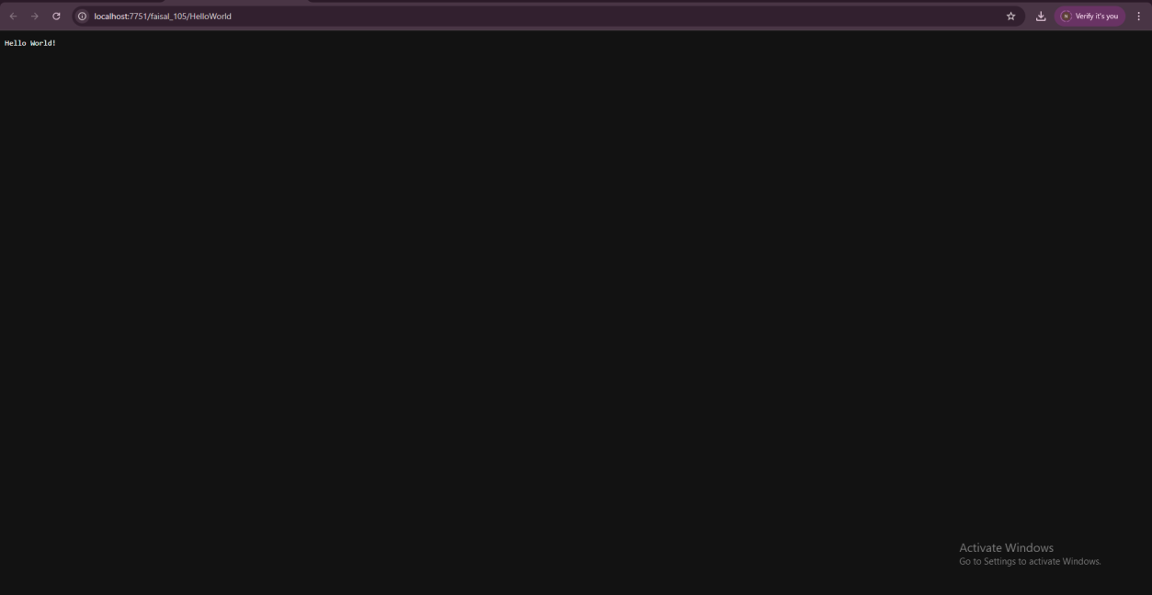

**RESULT:**

The servlet program successfully compiled and executed. It printed "HelloWorld" in the browser, demonstrating the use of a basic servlet using the doGet() method.